ATLAS – THE INTELLIGENT UNIVERSITY ECOSYSTEM
INTERNSHIP PROJECT
Submitted in partial fulfilment of the requirements for the award of
Bachelor of Science in Data Science (B.Sc Data Science)
By
V. SANTHOSH (44616038)
[UNIVERSITY CREST / DEPARTMENT LOGO]
SCHOOL OF SCIENCE & HUMANITIES
DEPARTMENT OF DATA SCIENCE
SATHYABAMA
INSTITUTE OF SCIENCE AND TECHNOLOGY
(DEEMED TO BE UNIVERSITY)
CATEGORY -1 UNIVERSITY BY UGC
Accredited with Grade “A++” by NAAC I 12B Status by UGC I Approved by AICTE
JEPPIAAR NAGAR, RAJIV GANDHI SALAI, CHENNAI - 600119
AUGUST – 2026

SATHYABAMA
INSTITUTE OF SCIENCE AND TECHNOLOGY
(DEEMED TO BE UNIVERSITY)
Category - I University by UGC
Accredited “A++” by NAAC | Approved by AICTE
www.sathyabama.ac.in
DEPARTMENT OF DATA SCIENCE
BONAFIDE CERTIFICATE
This is to certify that this Project Report is the Bonafide work of V. SANTHOSH (44616038) who carried out the Project entitled “ATLAS – THE INTELLIGENT UNIVERSITY ECOSYSTEM” under my supervision from 24 June 2026 to 24 July 2026.

Internal Guide
Ms. MEGHA
Head of the Department
[HOD NAME, DESIGNATION]
Submitted for Internship Viva Voce Examination held on ______________________
Internal Examiner External Examiner

DECLARATION
I, V. Santhosh (44616038) hereby declare that the Project Report entitled “Atlas – The Intelligent University Ecosystem” done by me under the guidance of Ms. Megha, is submitted in partial fulfilment of the requirements for the award of Bachelor of Science in Data Science (B.Sc Data Science).

DATE:
PLACE: Chennai SIGNATURE OF THE CANDIDATE

ACKNOWLEDGEMENT
I am pleased to acknowledge my sincere thanks to the Board of Management of Sathyabama Institute of Science and Technology for their kind encouragement in doing this project and for completing it successfully. I am grateful to them.
I convey my thanks to Dr. REKHA CHAKRAVARTHI, M.E., Ph.D., Dean, School of Science & Humanities, and [HOD NAME, Head of the Department of Data Science] for providing me the necessary support and details at the right time during the progressive reviews.
I wish to express my sincere and deep sense of gratitude to my Project Guide, Ms. Megha, for her valuable guidance, suggestions, and constant encouragement, which paved the way for the successful completion of my project work.
I also wish to thank all the Teaching and Non-Teaching staff members of the Department of Data Science who were helpful in many ways during the completion of this project.

ABSTRACT
Atlas is a web-based university management platform built on a Flask backend that brings together the day-to-day academic tools used by students, faculty and administrators into a single, role-aware system. Rather than requiring separate logins and separate tools for attendance tracking, assignment management, internship applications and academic analytics, Atlas presents each user with a dashboard tailored to their role – Student, Faculty or Administrator – and consolidates the data those users need behind a single authentication layer backed by a PostgreSQL database.
For students specifically, Atlas centres around a Smart Dashboard that surfaces current GPA, average attendance, pending tasks and an ongoing study streak, alongside AI-generated insights that flag assignments needing attention and attendance shortfalls before they become a problem. An integrated AI Workspace offers a set of academic productivity tools – including note summarisation, quiz generation, concept explanation, a day-by-day study planner, a resume analyser, an internship matcher, an attendance risk predictor and a holistic student success summary – that a student can invoke directly from within the platform. A dedicated Analytics view turns raw attendance and task data into charts – a per-course attendance bar chart and a task-breakdown donut chart – so that trends are visible at a glance rather than buried in a table. The platform also includes an Internship Portal that lists opportunities with an AI-calculated compatibility score against the student's profile, alongside the skills required and stipend on offer for each listing.
Atlas was developed and tested end-to-end during the internship period, covering authentication and demo account handling, the student-facing dashboard and its constituent widgets, the AI Workspace tools, the analytics and reporting views, and the internship discovery portal. This report documents the motivation for the project, a review of related systems, the design and architecture of Atlas, its implementation across these modules, and the results observed during testing, along with a discussion of possible future enhancements.

TABLE OF CONTENTS

1. INTRODUCTION
Modern university campuses run on a patchwork of separate systems: one portal for attendance, another spreadsheet or LMS for assignments, a separate careers office or job board for internships, and yet another system – or no system at all – for personalised study guidance. Students and faculty end up switching between disconnected tools to get a complete picture of academic progress, and administrators lack a single place from which to oversee the institution.
This project, Atlas – The Intelligent University Ecosystem, addresses this fragmentation by building a single Flask-based web platform that brings student, faculty and administrative functions together behind one authentication system and one PostgreSQL database. Rather than treating each function as an isolated tool, Atlas organises them around role-based dashboards: a Student Dashboard focused on academic performance and day-to-day tasks, a Faculty Dashboard for managing courses and students, and an Admin Dashboard for institution-wide oversight.
A distinguishing feature of Atlas is its AI Workspace, a set of ten AI-assisted tools – including note summarisation, quiz generation, concept explanation, study planning, resume analysis, internship matching, attendance-risk prediction, and an overall student success summary – that a student can call on directly from the dashboard, using their own current academic data as the input. Combined with a dedicated Analytics section that visualises attendance and task-completion trends, and an Internship Portal that scores opportunities against the student's own skill profile, Atlas is intended to function as a day-to-day academic companion rather than a static record-keeping system.
The concept of unified, AI-assisted campus platforms sits at the intersection of several existing categories of software: traditional university ERP and student information systems, learning management systems (LMS), and, more recently, AI-powered productivity and recommendation tools. Each of these categories addresses part of the problem Atlas is aimed at, but typically not all of it at once.
Traditional Student Information Systems and campus ERPs are effective at recording structured data – attendance registers, marks, fee status – but are rarely designed to give students proactive, personalised guidance based on that data. Learning management systems such as those used for course content and assignment submission are strong on content delivery but weak on cross-cutting academic analytics or career-readiness features such as internship matching. Meanwhile, general-purpose AI assistants can summarise notes or explain concepts on request, but are not integrated with a student's actual institutional data – their attendance, GPA, or pending coursework – so their recommendations remain generic rather than personalised.
Atlas is designed to sit across these gaps: a single Flask application, backed by a PostgreSQL database of real academic records, that both stores institutional data in the traditional ERP sense and exposes that data to a set of AI-assisted tools so that recommendations, summaries and predictions are grounded in the student's actual academic situation rather than generic input.

2. LITERATURE SURVEY

2.1 Review of Existing Systems
The table below summarises related work and existing categories of systems relevant to Atlas. [PLACEHOLDER: Replace the rows below with the specific papers, articles, or existing-system reviews you have actually read and wish to cite, following your department's required citation style.]
S.No | Author(s) & Title | Year | Description | Drawbacks
1 | [PLACEHOLDER: citation] | [PLACEHOLDER] | [PLACEHOLDER: summary of a paper/article on university ERP or campus management systems] | [PLACEHOLDER: limitation noted]
2 | [PLACEHOLDER: citation] | [PLACEHOLDER] | [PLACEHOLDER: summary of a paper/article on AI-based student analytics or attendance prediction] | [PLACEHOLDER: limitation noted]
3 | [PLACEHOLDER: citation] | [PLACEHOLDER] | [PLACEHOLDER: summary of a paper/article on internship-matching or recommender systems] | [PLACEHOLDER: limitation noted]
4 | [PLACEHOLDER: citation] | [PLACEHOLDER] | [PLACEHOLDER: summary of a paper/article on Flask-based web application architecture] | [PLACEHOLDER: limitation noted]
5 | [PLACEHOLDER: citation] | [PLACEHOLDER] | [PLACEHOLDER: summary of a paper/article on role-based access control in academic systems] | [PLACEHOLDER: limitation noted]

2.2 Gaps and Challenges in Existing Systems
- Fragmented Data Across Systems – Attendance, assignments, internships and study planning are typically handled by separate, disconnected tools, making it difficult for a student to get a single view of their academic standing.
- Lack of Personalised, Data-Grounded AI Assistance – Where AI tools exist, they are often generic and not connected to the student's actual institutional records, limiting the usefulness of their output.
- Limited Role-Based Design – Many campus systems are built primarily for administrators, with student- and faculty-facing views added on afterward rather than designed as first-class experiences.
- Weak Career-Readiness Integration – Internship and placement discovery is usually handled outside the academic system entirely, disconnected from a student's coursework, attendance or skill profile.
- High Setup and Maintenance Overhead – Legacy ERP systems are often expensive to license, difficult to customise, and slow to extend with new modules such as analytics dashboards or AI tools.

3. ANALYSIS AND DESIGN OF PROPOSED SYSTEM

3.1 Need for the Proposed System
As outlined in Chapter 1, students and staff currently rely on multiple disconnected systems to manage attendance, coursework, analytics and internship discovery. This fragmentation results in duplicated data entry, inconsistent visibility into academic standing, and missed opportunities for early intervention when a student's attendance or task completion starts to fall behind. There is a need for a unified platform that can:
- Bring student, faculty and administrative functions into a single, role-aware system.
- Present academic data – GPA, attendance, task progress – in a clear, dashboard-first format.
- Offer AI-assisted tools that operate directly on a student's own current data rather than generic input.
- Provide visual analytics that make attendance and task trends immediately visible.
- Connect academic performance to career readiness through an integrated internship portal.

3.2 Hardware and Software Requirements
Hardware Requirements:
Component | Requirement
Processor | Dual-core or higher
RAM | 4 GB minimum
Storage | 2 GB free disk space
Network | Stable internet connection
Device | Desktop, laptop, or smartphone with a modern web browser

Software Requirements:
Component | Requirement
Backend Framework | Flask (Python)
Database | PostgreSQL
Frontend | Responsive HTML/CSS/JavaScript web interface
AI Integration | AI model API for the AI Workspace tools
Browser | Any modern web browser (Chrome, Edge, Firefox)

3.3 Architecture Diagram
Atlas follows a layered web-application architecture. Users interact with the system through a browser-based client, which presents role-specific views (Student, Faculty, or Administrator) once authenticated. All requests are handled by a central Flask application server responsible for authentication, routing and session management. The Flask server delegates functional requests to dedicated modules – Attendance Analytics, Study Planner / Internship Portal, the AI Workspace, and Admin Control – each of which reads from and writes to a shared PostgreSQL database. AI Workspace requests that require natural-language processing (such as note summarisation or concept explanation) are additionally routed to an AI model API. This modular structure keeps each functional area independent while sharing a single, consistent data layer.
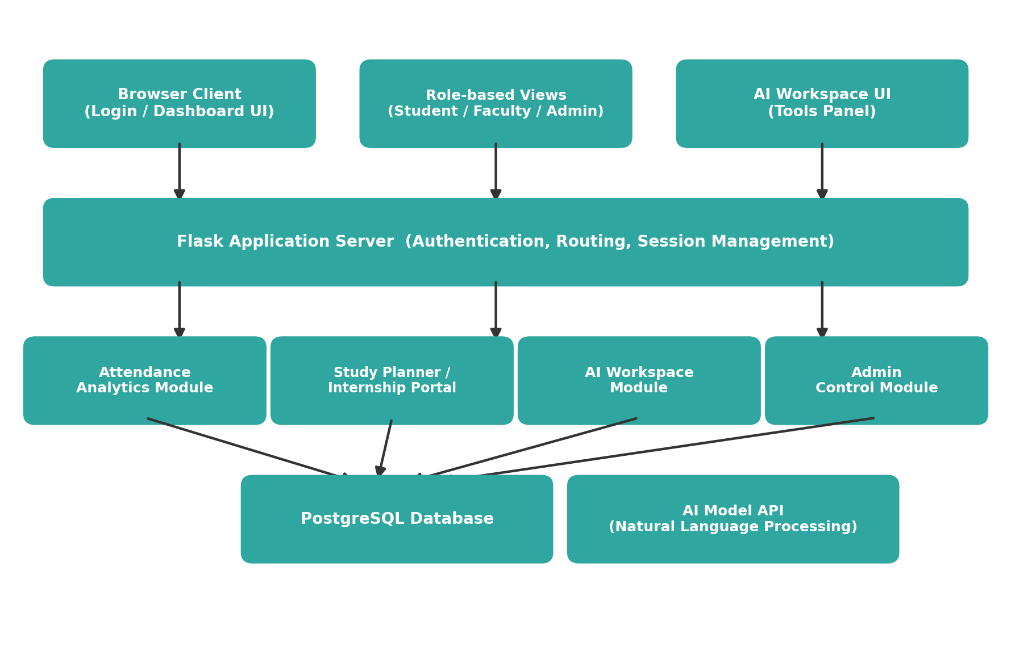
Figure 3.1 – Architectural Diagram of Atlas

4. IMPLEMENTATION OF PROPOSED SYSTEM

4.1 Database Used
Atlas uses PostgreSQL as its primary data store. Using a relational database in place of ad-hoc file or spreadsheet storage gives the platform several advantages:
- Structured, Relational Data: Students, courses, attendance records, tasks and internship listings are modelled as related tables, supporting reliable queries across modules.
- Data Integrity: Constraints at the database level help keep records such as attendance percentages and GPA consistent as they are updated.
- Concurrent, Multi-Role Access: Students, faculty and administrators can access and update relevant data at the same time without conflicts.
- Scalability: PostgreSQL can scale to support the institution's full student and faculty population as usage grows.

4.2 Modules Employed
- Authentication System – Handles sign-in for Student, Faculty and Administrator roles, including a demo-mode account picker for evaluation purposes.
- Student Dashboard – The primary landing view for students, surfacing current GPA, average attendance, pending tasks, study streak, AI-generated insights, an attendance summary by course, upcoming assignments, announcements and study groups.
- Faculty Dashboard – [PLACEHOLDER: describe the Faculty-facing view once screenshots/details of this module are available.]
- Admin Dashboard – [PLACEHOLDER: describe the Admin-facing view once screenshots/details of this module are available.]
- AI Workspace – A set of ten AI-assisted tools (Summarize Notes, Generate Quiz, Explain Concept, Study Planner, Resume Analyzer, Internship Matcher, Attendance Predictor, Student Success Summary, Smart Daily Insights, and history tracking via Recent Prompts) that operate on the student's own dashboard data or an uploaded file.
- Attendance Analytics – A dedicated Analytics view showing average attendance, average task progress, active task count and current CGPA, alongside a per-course attendance bar chart and a Completed / In Progress / Pending task-breakdown donut chart.
- Internship Portal – Lists internship opportunities with company, location, stipend, required skills, and an AI-calculated match percentage against the student's profile, with Save and Apply actions.
- Study Planner – Generates a personalised, day-by-day study schedule based on the student's subjects and deadlines.
- Responsive Web Interface – A consistent, dark-themed interface that adapts across the Dashboard, AI Tools, Analytics and Internships sections, accessible from a persistent top navigation bar.

4.3 Workflow of the Proposed System
- User Authentication – The user signs in through the login screen, selecting or entering credentials for their role (Student, Faculty, or Administrator).
- Dashboard Load – On successful login, Flask queries PostgreSQL for the user's current academic data and renders the role-appropriate dashboard.
- Module Navigation – The user moves between Dashboard, AI Tools, Analytics and Internships using the top navigation bar; each section is served by its own Flask route and corresponding module.
- AI Tool Invocation – When a student runs an AI Workspace tool (e.g. Student Success Summary), the current dashboard data – or an uploaded file – is passed to the AI model API, and the generated output is displayed in the AI Workspace panel and logged under Recent Prompts.
- Analytics Rendering – The Analytics module aggregates attendance and task data per course and renders it as charts (bar chart for attendance, donut chart for task breakdown).
- Internship Matching – The Internship Portal compares the student's stored skill profile against each listed opportunity and displays a match percentage, allowing the student to save or apply.
- Data Persistence – Any updates – completed tasks, saved internships, generated study plans – are written back to PostgreSQL so that they persist across sessions.

4.4 Functional Output
- Academic Overview: Displays current GPA, average attendance, pending tasks and study streak on a single dashboard.
- AI-Assisted Insights: Surfaces prioritised insights such as assignments needing attention or attendance dipping below target.
- Attendance Analytics: Presents attendance broken down by individual course, alongside a task-completion breakdown.
- Internship Matching: Recommends internship listings with a compatibility score, required skills, and stipend information.
- AI Workspace Tools: Provides note summarisation, quiz generation, concept explanation, study planning, resume analysis and more, on demand.

4.5 Advantages
- Unified Interface: A single login and navigation bar covers Dashboard, AI Tools, Analytics and Internships.
- Role-Aware Design: Distinct dashboards for Student, Faculty and Administrator roles, each showing only relevant data.
- Data-Grounded AI: AI Workspace tools operate on the student's actual academic data rather than generic input.
- Visual Analytics: Attendance and task trends are presented as charts rather than raw tables, making patterns easier to spot.
- Scalable, Modular Design: Built on Flask and PostgreSQL, allowing additional modules to be added without redesigning the core system.

5. RESULTS AND DISCUSSION
Atlas was developed and tested using its Flask backend and PostgreSQL database, with functionality verified across the Student Dashboard, AI Workspace, Analytics and Internship Portal modules. The following section presents the code overview followed by screenshots of the working application.

5.1 Code Overview
Atlas is implemented as a Flask application with server-rendered and dynamically updated views, backed by a PostgreSQL database for persistent storage.

5.1.1 Key Logic Components
- Authentication Module – Validates user credentials and establishes a session tied to the user's role (Student, Faculty, or Administrator), including a Demo Mode for quick evaluation via preset accounts.
- Dashboard Route – Queries PostgreSQL for the logged-in student's GPA, attendance, tasks and study-streak data, and renders the Smart Dashboard view.
- AI Insights Component – Evaluates the student's current data against simple thresholds (e.g. attendance below target, assignments due soon) to generate prioritised insight cards.
- AI Workspace Router – Accepts a selected tool (Summarize Notes, Generate Quiz, Resume Analyzer, etc.), an optional uploaded file, and the current dashboard context, then forwards the request to the AI model API and returns the formatted result.
- Analytics Aggregator – Computes per-course attendance percentages and a Completed / In Progress / Pending task breakdown, which are rendered as a bar chart and a donut chart respectively.
- Internship Matching Logic – Compares the student's stored skills against each internship listing's required skills to compute a match percentage.
[PLACEHOLDER: If you would like to include actual code excerpts – for example, the Flask route for the dashboard or the internship-matching function – insert them here as a formatted code block, along with a short explanation of the logic.]

5.2 Screenshots of Application
Figure 5.1 shows the Atlas AI landing page, introducing the platform and its core value proposition of unifying student learning, faculty management and institutional analytics.
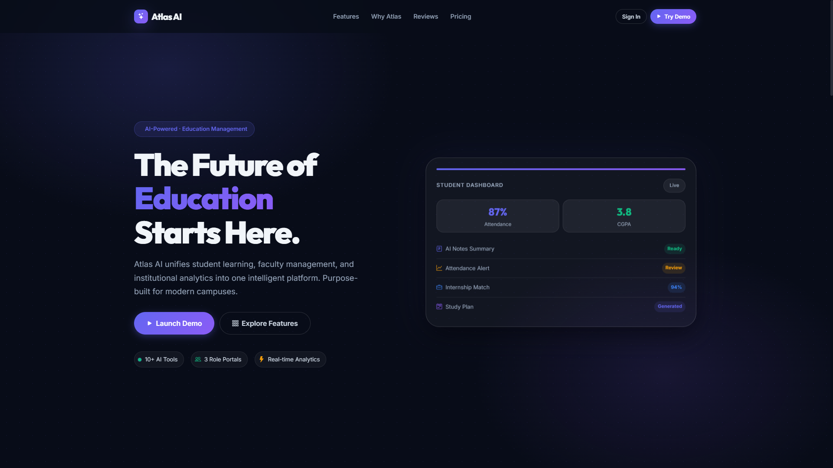
Figure 5.1 – Atlas AI Landing Page
Figure 5.2 shows the sign-in screen, which supports role-based login (Administrator, Student, Faculty) and includes a Demo Mode with one-click demo accounts for evaluation purposes.
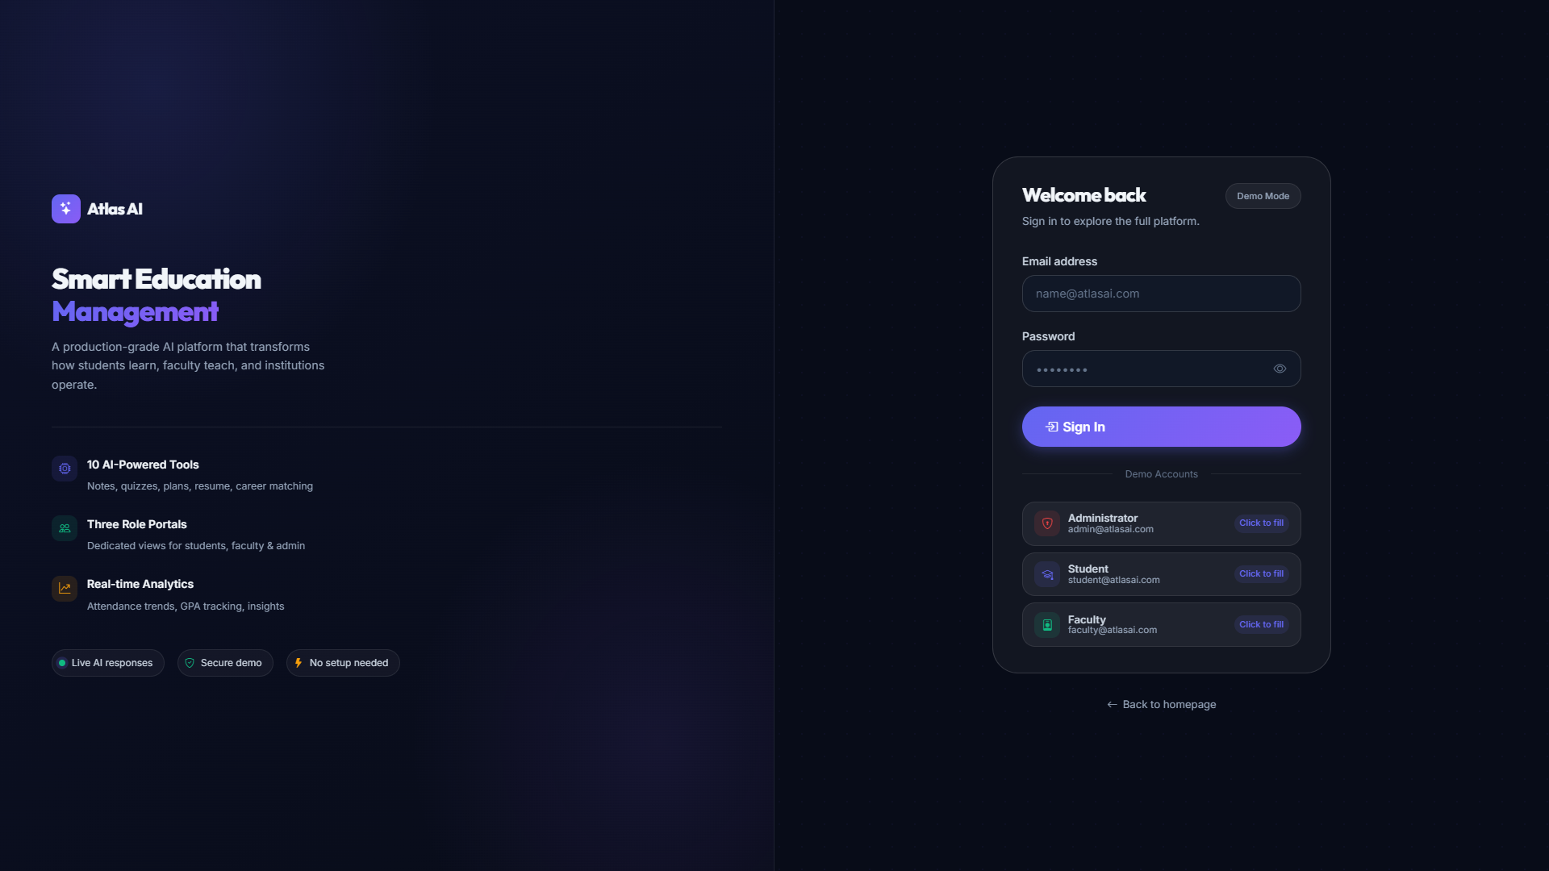
Figure 5.2 – Login / Sign-In Screen
Figure 5.3 shows the Student Dashboard immediately after login, displaying current GPA, average attendance, pending tasks and study streak, along with AI Insights and a per-course Attendance summary.
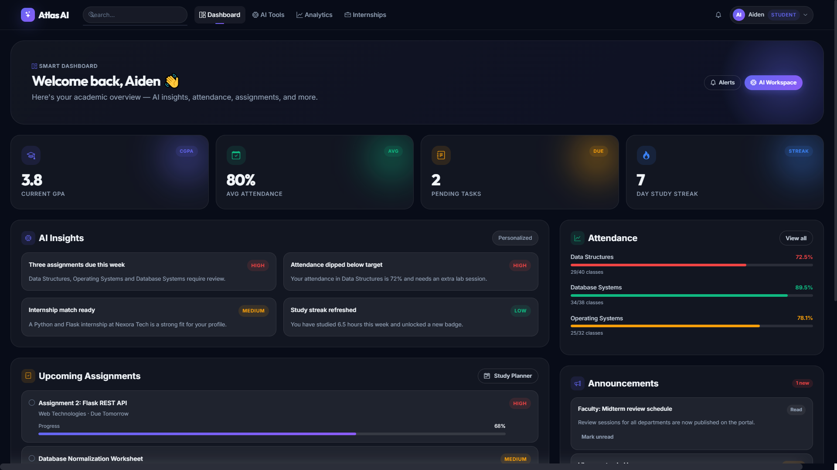
Figure 5.3 – Student Dashboard – Overview
Figure 5.4 shows the lower portion of the Student Dashboard, including Upcoming Assignments with progress bars, Announcements, Quick Actions, and Study Groups the student can join.
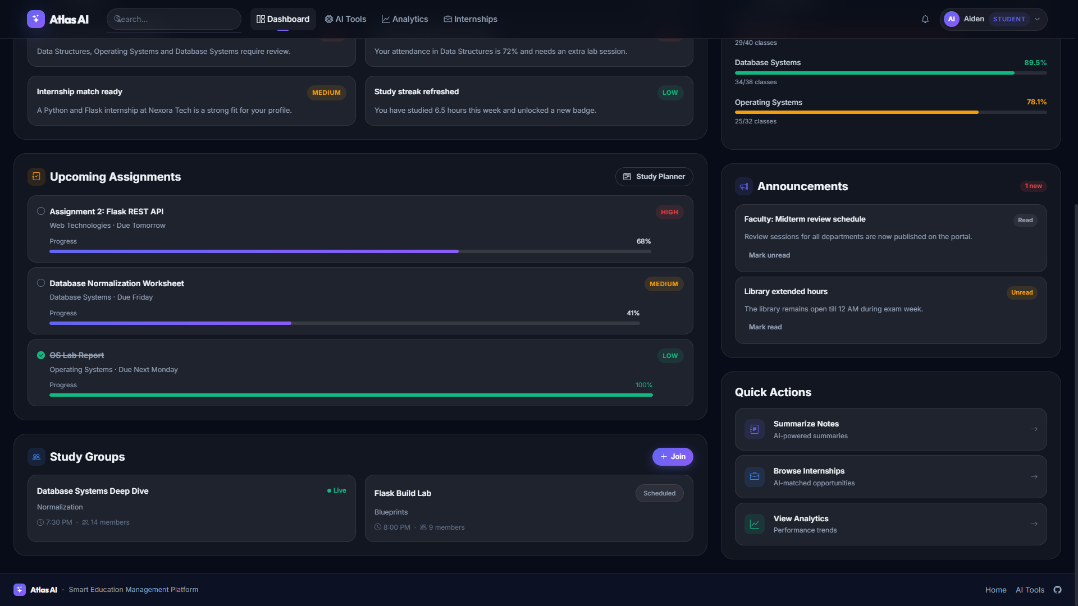
Figure 5.4 – Student Dashboard – Assignments, Announcements & Quick Actions
Figure 5.5 shows the AI Workspace, listing the ten available AI-assisted tools – including Summarize Notes, Generate Quiz, Explain Concept, Study Planner, Resume Analyzer, Internship Matcher, Attendance Predictor, Student Success Summary and Smart Daily Insights – along with the input panel used to run a selected tool.
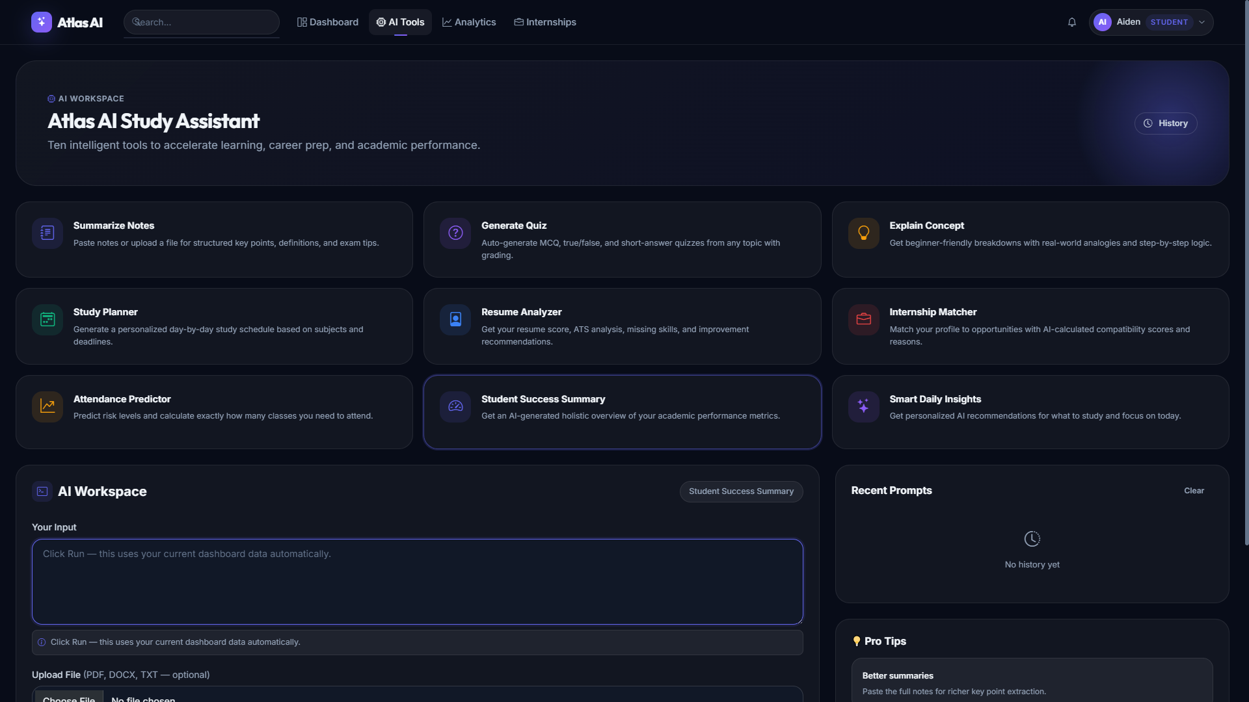
Figure 5.5 – AI Workspace – Study Assistant Tools
Figure 5.6 shows the Analytics section's Performance Overview, presenting average attendance, average task progress, active task count and current CGPA, together with an Attendance by Course chart and a Task Breakdown donut chart.
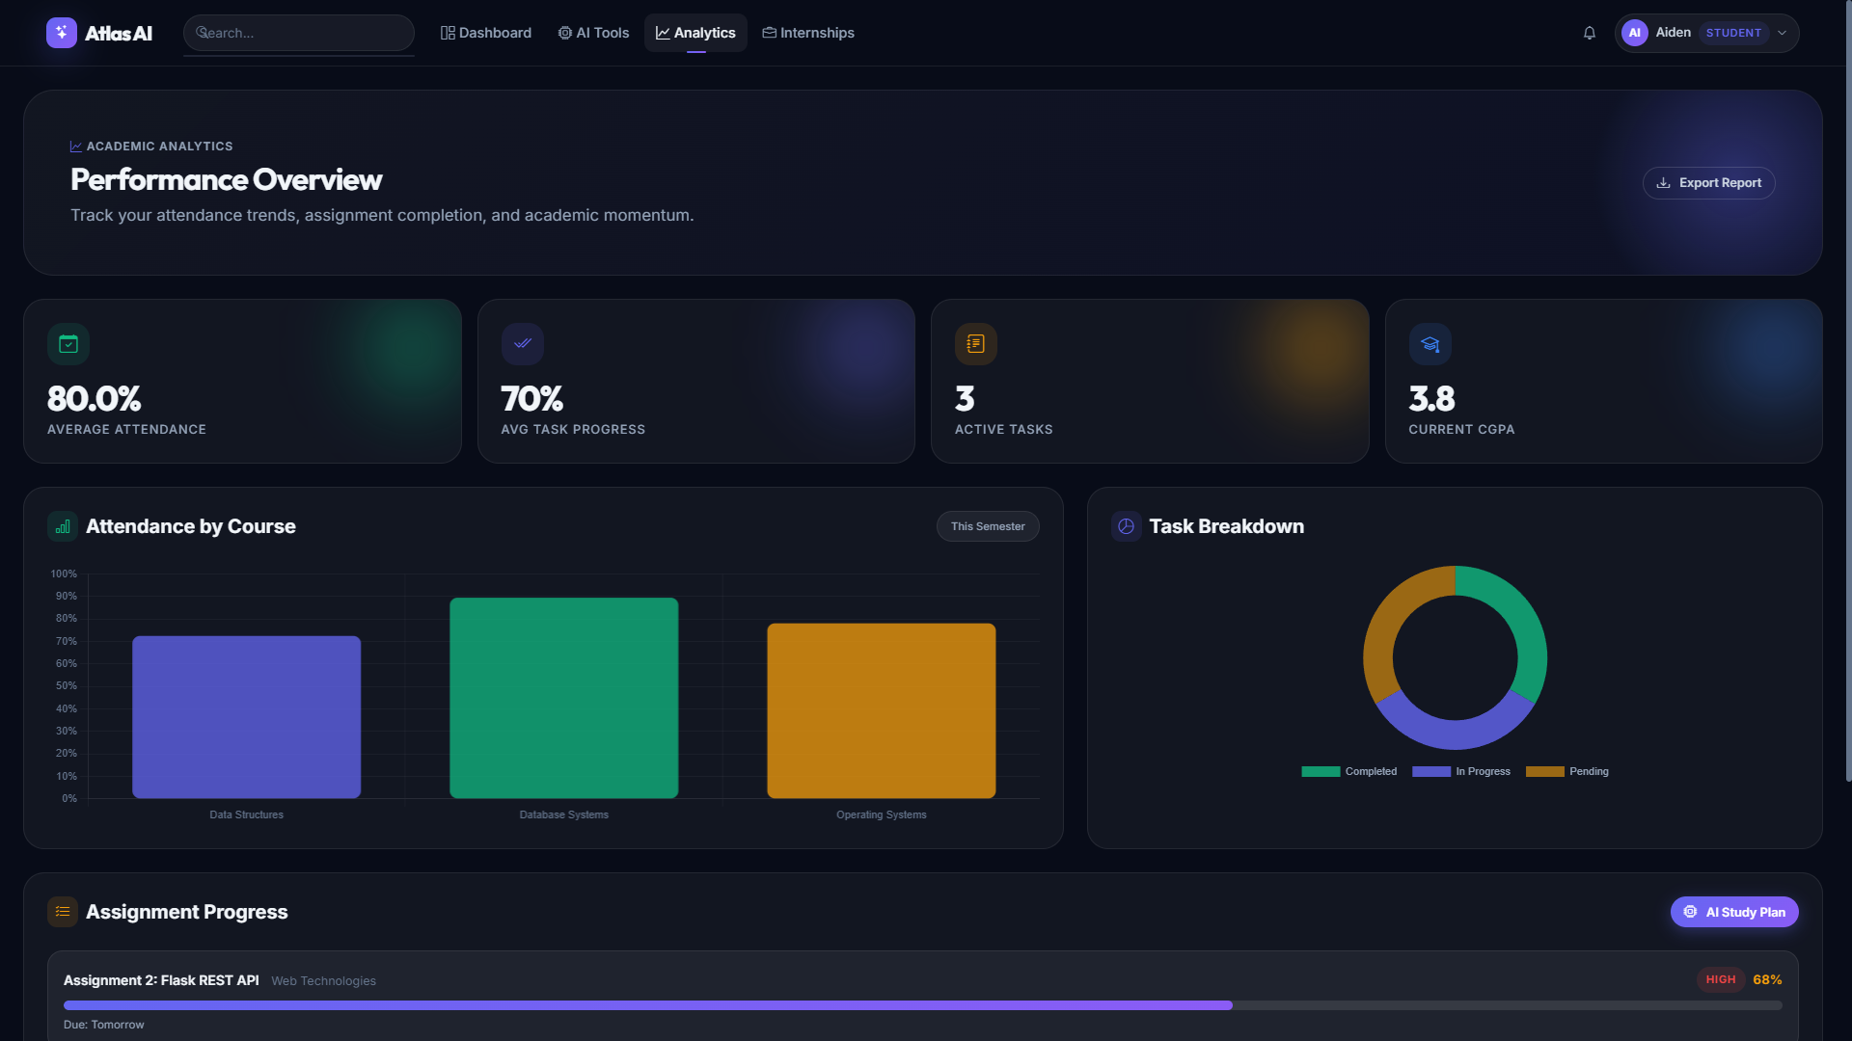
Figure 5.6 – Analytics – Performance Overview
Figure 5.7 shows the lower portion of the Analytics section, including the full Attendance by Course chart, Task Breakdown chart and per-assignment progress bars under Assignment Progress.
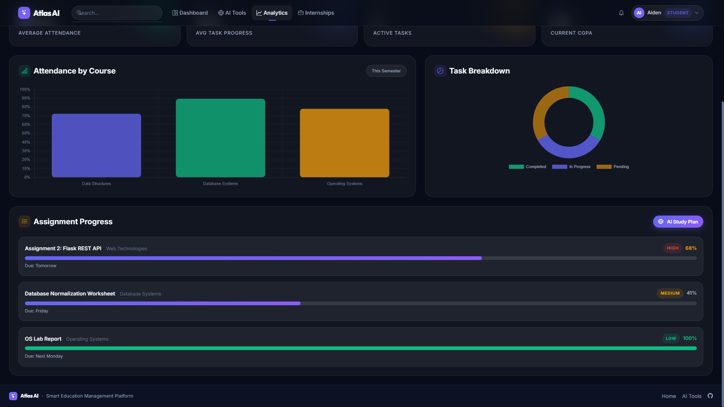
Figure 5.7 – Analytics – Attendance and Assignment Progress
Figure 5.8 shows the Internship Portal, listing available internships with company, location, a short description, required skills, stipend, and an AI-calculated match percentage against the student's profile.
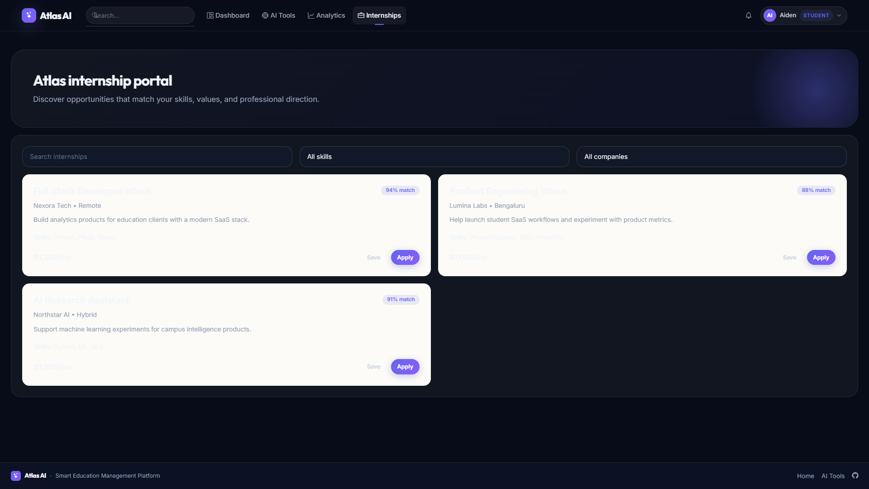
Figure 5.8 – Internship Portal

6. CONCLUSION AND FUTURE ENHANCEMENTS

6.1 Conclusion
Atlas demonstrates how a Flask-based web platform, backed by a PostgreSQL database, can unify the previously fragmented functions of a university campus – attendance tracking, assignment management, academic analytics, and internship discovery – into a single, role-aware system. The Student Dashboard, AI Workspace, Analytics and Internship Portal modules together give students a consolidated, real-time view of their academic standing, while the underlying AI Workspace tools ground their recommendations in the student's own current data rather than generic input. The modular design, with each functional area implemented as an independent module sharing a common database, made it possible to develop, test and extend individual features – such as the internship matcher or attendance predictor – without disrupting the rest of the system.

6.2 Future Enhancements
- Faculty and Admin Module Expansion – Building out the Faculty and Admin dashboards with the same depth of functionality currently available to students.
- Mobile Application – Extending Atlas to a native or progressive web app for on-the-go access to dashboards and notifications.
- Push Notifications – Real-time alerts for attendance drops, assignment deadlines and internship matches, rather than requiring the student to check the dashboard.
- Deeper LMS Integration – Connecting Atlas to existing learning management or course-content systems so that assignment data is captured automatically.
- Enhanced Security – Strengthening authentication with multi-factor login, encrypted data storage, and more granular role-based permissions.
- Expanded Analytics – Adding semester-over-semester trend analysis and predictive alerts for at-risk students, beyond the current single-semester view.

REFERENCES
[PLACEHOLDER: Add references actually used for this report – e.g. Flask documentation, PostgreSQL documentation, any papers cited in Chapter 2, and documentation for any AI model API used – formatted per your department's required citation style.]
- [PLACEHOLDER: Author(s). (Year). Title. Source. URL if applicable.]
- [PLACEHOLDER: Author(s). (Year). Title. Source. URL if applicable.]
- [PLACEHOLDER: Author(s). (Year). Title. Source. URL if applicable.]

